# Proof of completion:

1. Using the below screenshot prooving that I have completed the problem set
2. 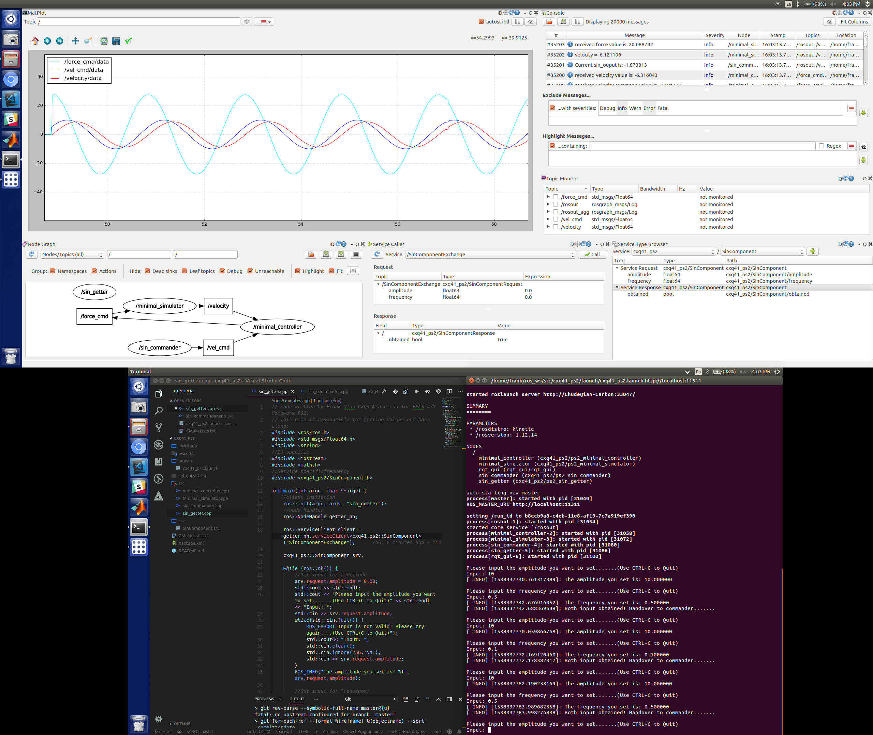Showing update of amplitude works:

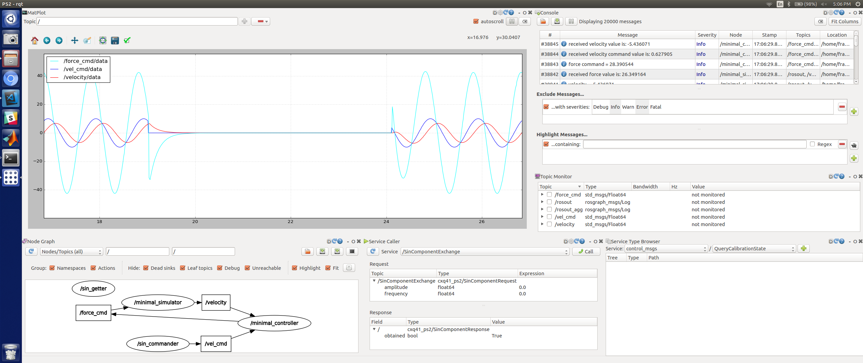

1. Showing update of frequency works:

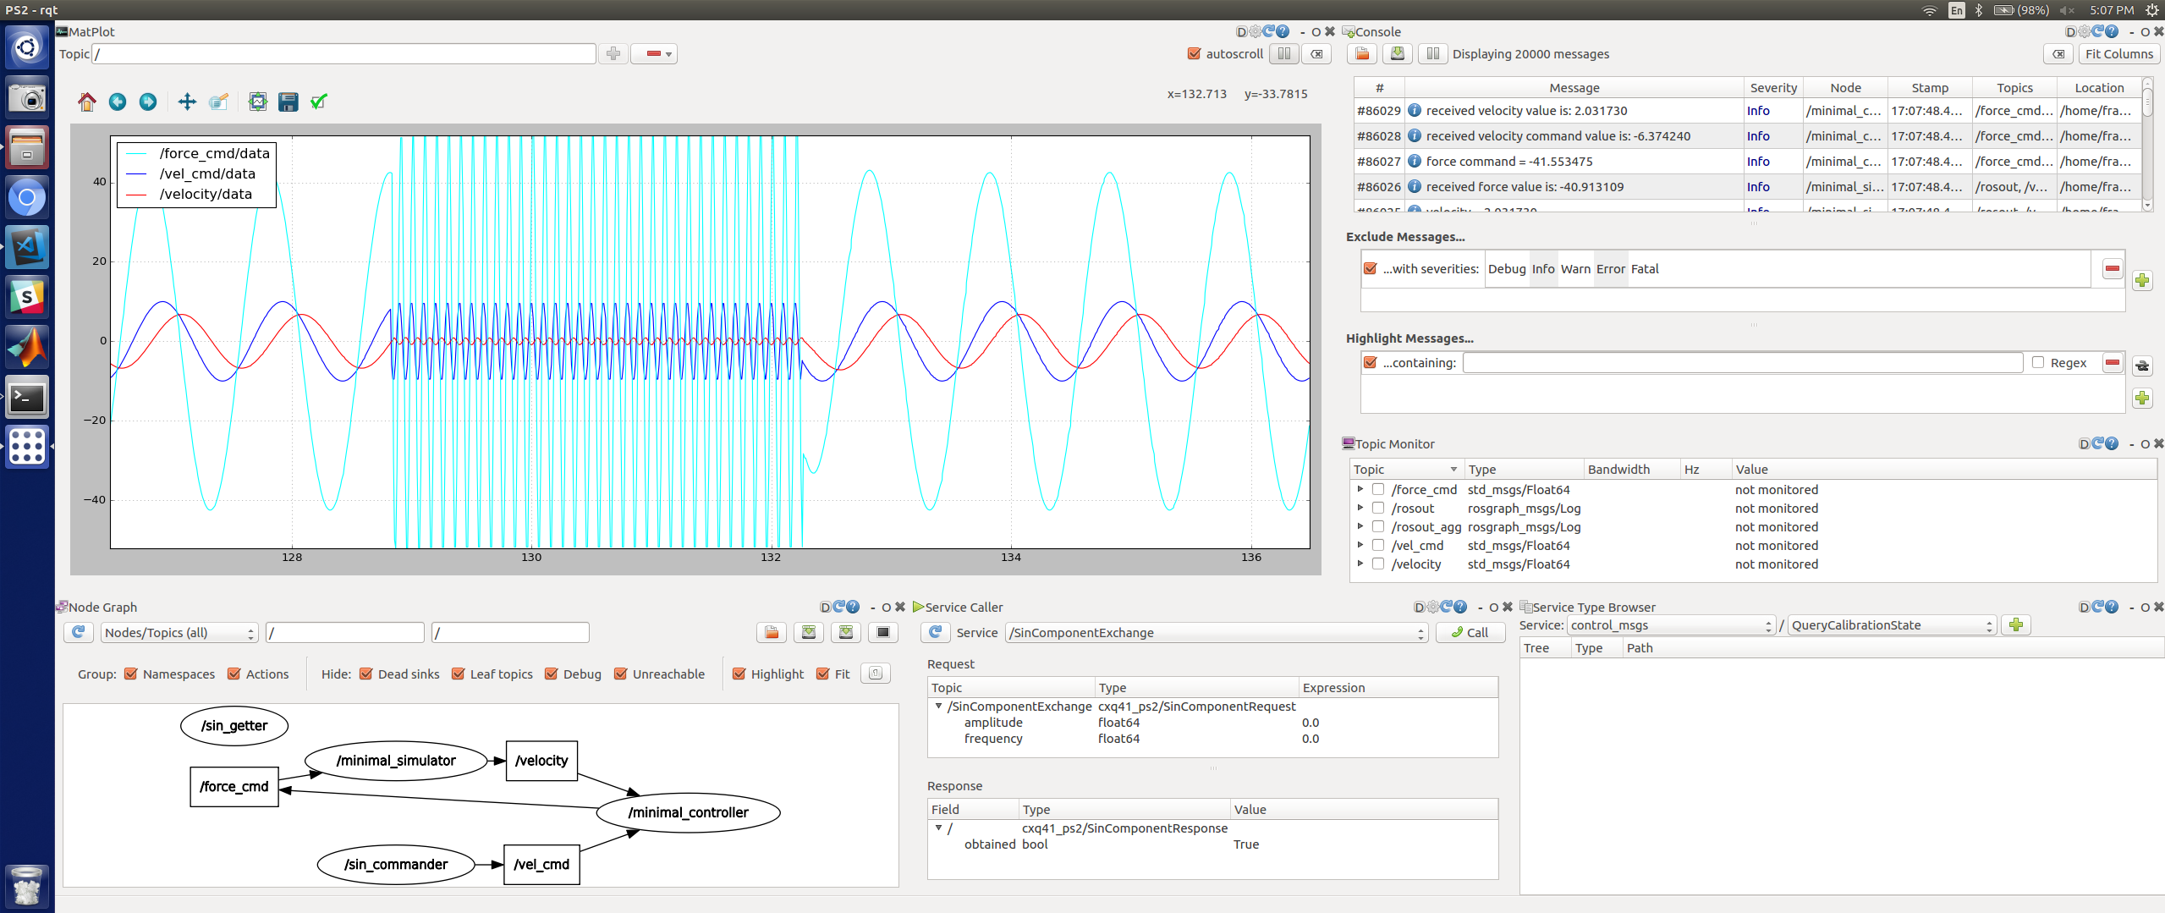

**Code included in zip file.**